|  |  |  |  |  |
| --- | --- | --- | --- | --- |
| 5 | 6 | 9 | 3 | 5 |
| 9 | 3 | 6 | 5 | 8 |
| 1 | 2 | 5 | 6 | 3 |
| 7 | 0 | 3 | 6 | 9 |
| 0 | 5 | 8 | 6 | 3 |

[2:4, 1:3]

[0, 1:]

[2:, 4]

|  |  |  |  |  |
| --- | --- | --- | --- | --- |
| 5 | 6 | 9 | 3 | 5 |
| 9 | 3 | 6 | 5 | 8 |
| 1 | 2 | 5 | 6 | 3 |
| 7 | 0 | 3 | 6 | 9 |
| 0 | 5 | 8 | 6 | 3 |

[5, 1]

[-1, -1]

[2, 1]

[0, 0]

|  |  |  |  |  |
| --- | --- | --- | --- | --- |
| 5 | 6 | 9 | 3 | 5 |
| 9 | 3 | 6 | 5 | 8 |

|  |  |  |  |  |
| --- | --- | --- | --- | --- |
| 5 | 6 | 9 | 3 | 5 |
| 9 | 3 | 6 | 5 | 8 |

|  |  |  |  |  |
| --- | --- | --- | --- | --- |
| 5 | 6 | 9 | 3 | 5 |
| 9 | 3 | 6 | 5 | 8 |

|  |  |  |  |  |  |  |  |  |  |
| --- | --- | --- | --- | --- | --- | --- | --- | --- | --- |
| 5 | 6 | 9 | 3 | 5 | 9 | 3 | 6 | 5 | 8 |

|  |  |
| --- | --- |
| 5 | 9 |
| 6 | 3 |
| 9 | 6 |
| 3 | 5 |
| 5 | 8 |

|  |  |  |  |  |
| --- | --- | --- | --- | --- |
| 5 | 6 | 9 | 3 | 5 |
| 9 | 3 | 6 | 5 | 8 |

|  |  |  |  |  |
| --- | --- | --- | --- | --- |
| 5 | 6 | 9 | 3 | 5 |
| 9 | 3 | 6 | 5 | 8 |

|  |  |  |  |  |
| --- | --- | --- | --- | --- |
| 5 | 6 | 9 | 3 | 5 |
| 9 | 3 | 6 | 5 | 8 |
| 6 | 1 | 8 | 7 | 1 |
| 1 | 8 | 9 | 3 | 5 |

|  |  |  |  |  |  |  |  |  |  |
| --- | --- | --- | --- | --- | --- | --- | --- | --- | --- |
| 5 | 6 | 9 | 3 | 5 | 9 | 3 | 6 | 5 | 8 |
| 6 | 1 | 8 | 7 | 1 | 1 | 8 | 9 | 3 | 5 |

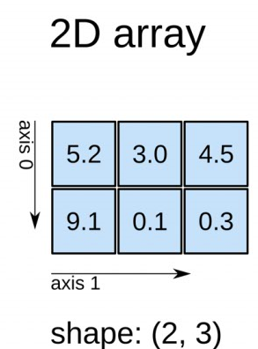

Number of elements: 6

Type: float64

Size in bytes: 8

|  |  |
| --- | --- |
| 0 | 6 |
| 1 | 3 |
| 2 | 1 |
| 3 | 8 |

**Index**

**Values**